Step 1: Download and Open the Project
- Download Activity 11.2.zip
- Extract the ZIP file.
- Open the extracted folder in VS Code.
- Locate: app.py

app.py in VS Code
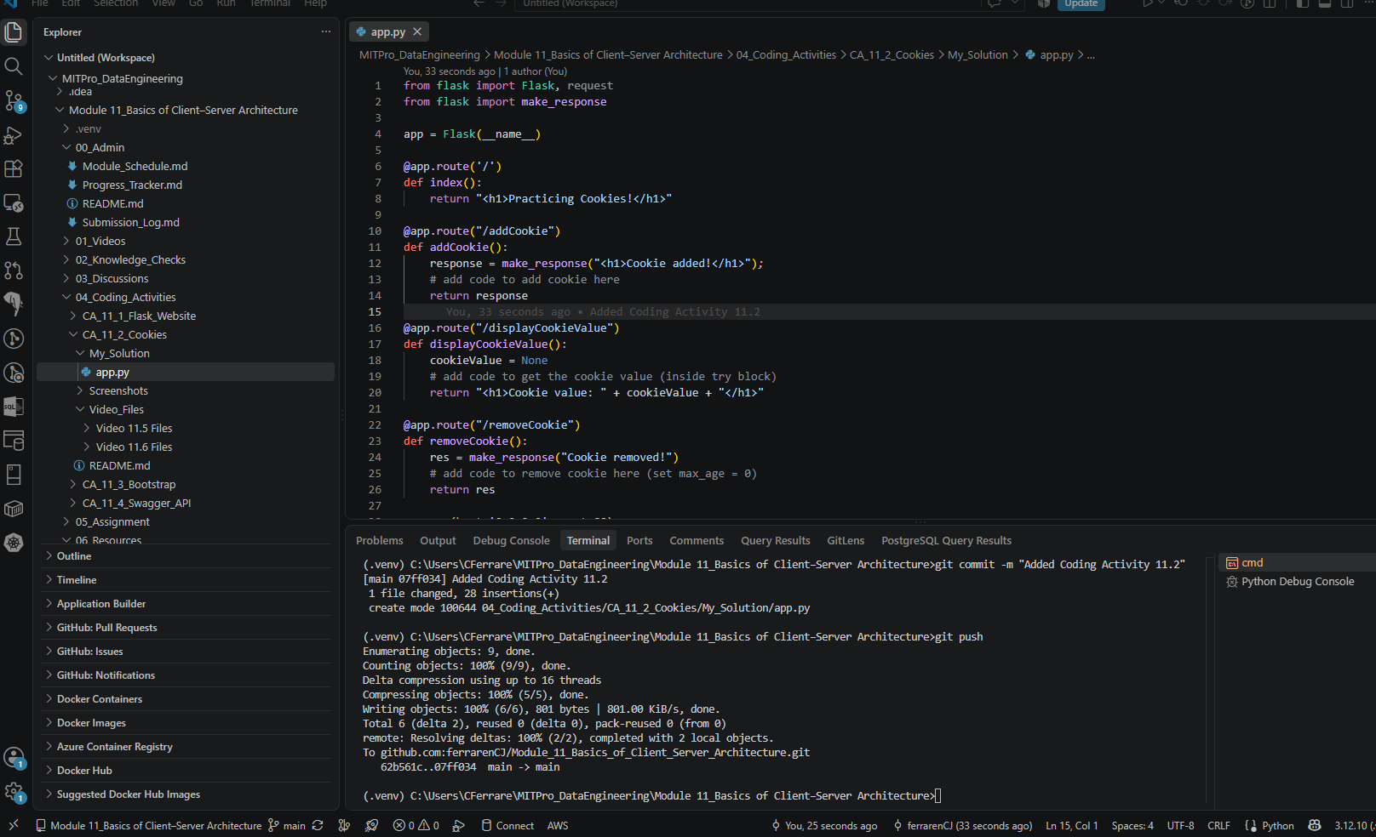

Step 2: Run the Application
- Open a terminal in VS Code.
- Run: python app.py

Browser displaying "Practicing Cookies!"
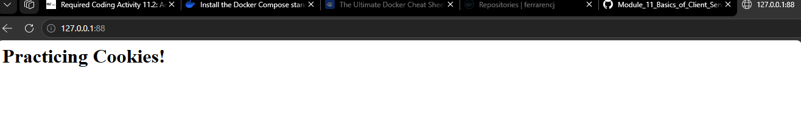
Step 3: Complete addCookie()
Locate: def addCookie():
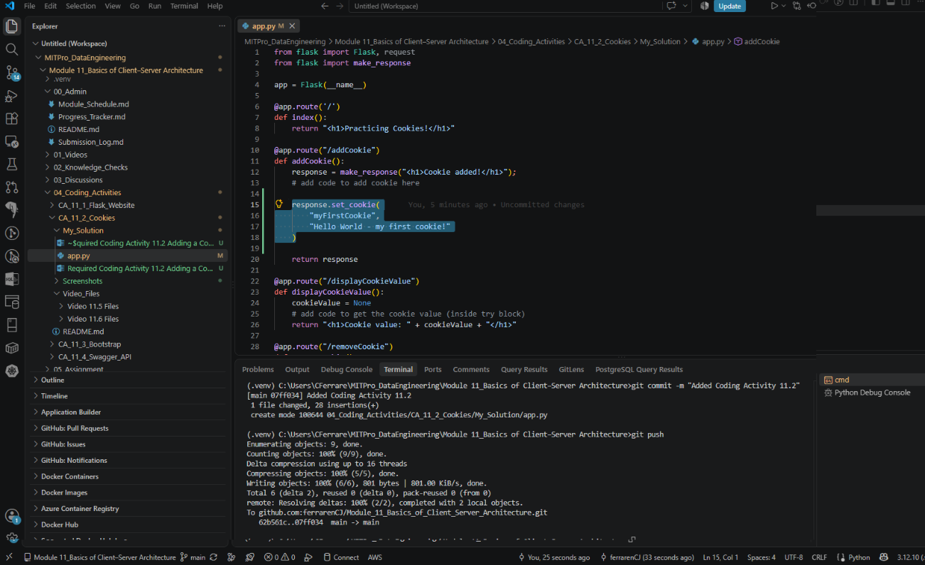

Step 4: Run the web application and navigate to “http://localhost:88/addCookie”.
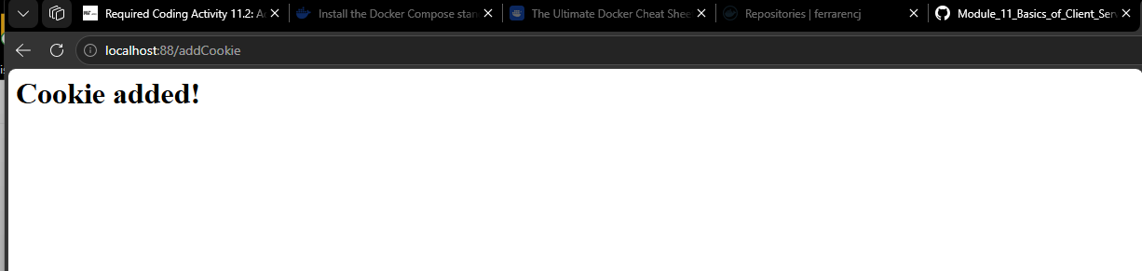
4a. Verify Cookie Exists
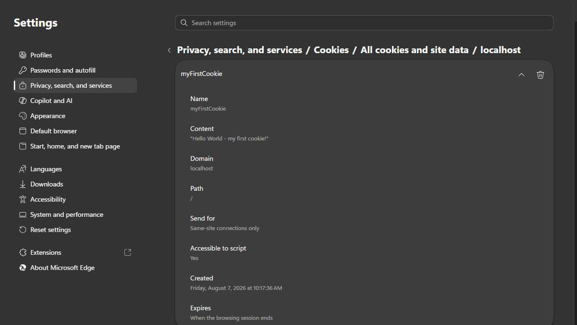
Step 5a: Complete displayCookieValue()
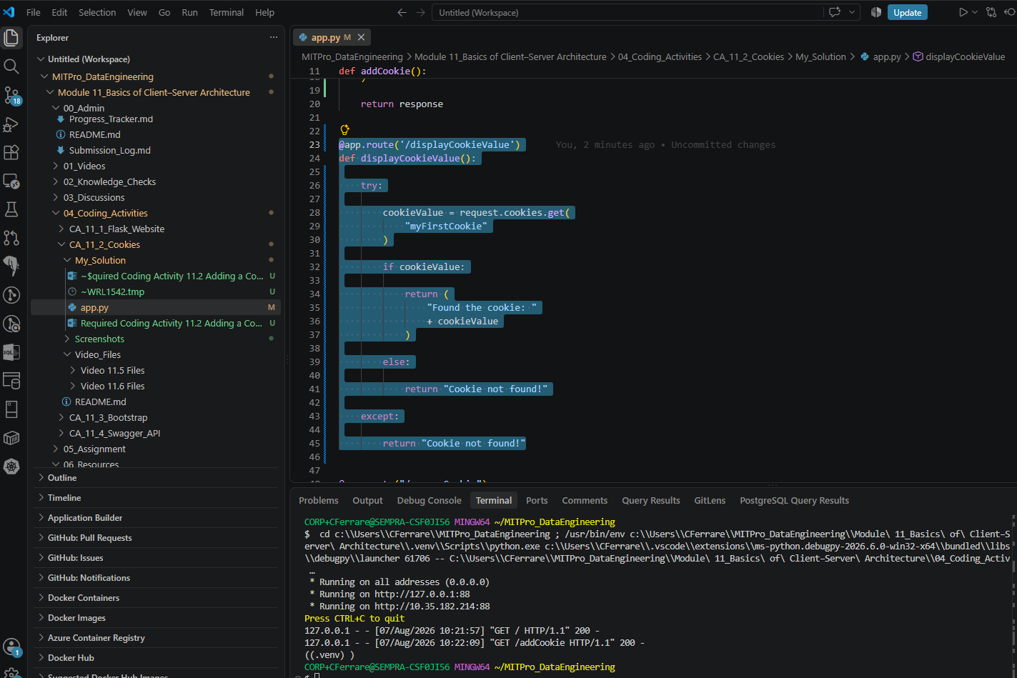
Step 5b. Navigate to “http://localhost:88/displayCookieValue” and look at the browser settings to confirm that your cookie was created.
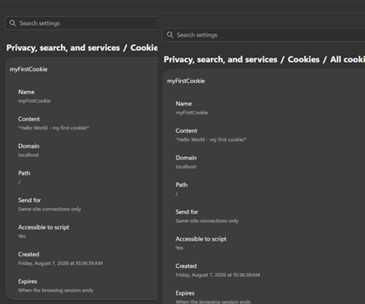

Step 6. From your browser settings, remove the cookie “myFirstCookie”. Now refresh the page “http://localhost:88/displayCookieValue”. Your page should display “Cookie Not Found!”
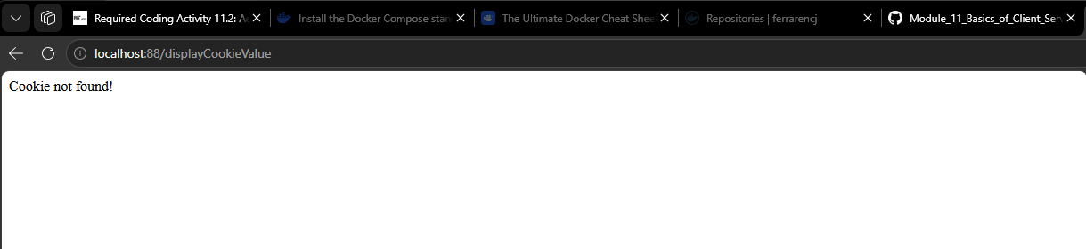

Step 7: Complete the method removeCookie. Add code to remove, or pop, the cookie “myFirstCookie”.
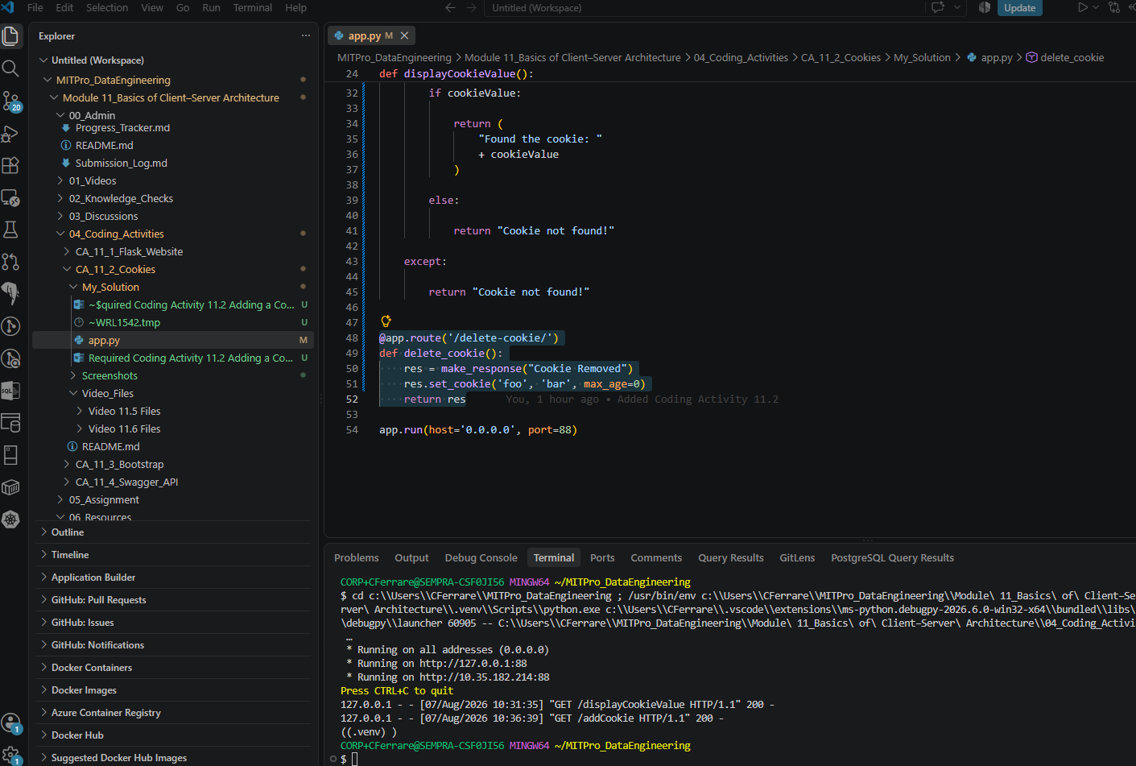

Step 8a: Navigate your browser to “http://localhost:88/addCookie”. Look at your browser settings and verify that the cookie has been created.
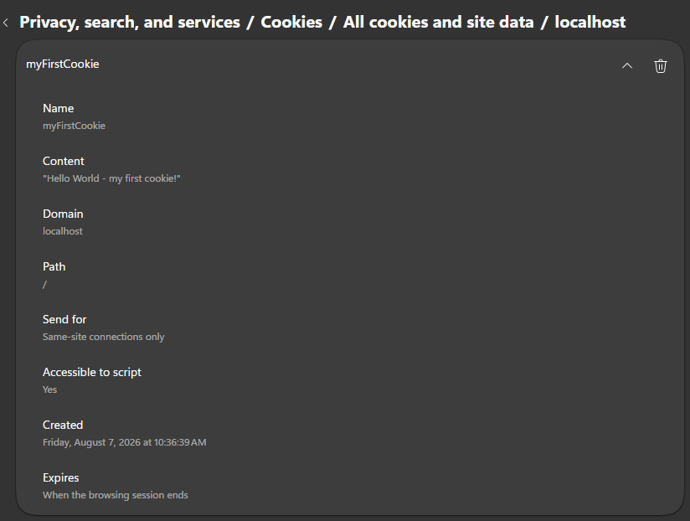

Step 8b: Test your new method “removeCookie” by navigating to “http://localhost:88/removeCookie” and confirm that the cookie has been removed from your browser.
